The Nanking Massacre
Objective: Identify, and infer what the Nanking Massacre was based on the documents below.
Culminating Task: Describe the Nanking Massacre, and assess the validity of the term, “The Rape of Nanking”. Must be about a page in length, use evidence from 3 or more documents to support your answer. You may do additional research if needed.
Doc 1
The Second Sino-Japanese War (Chinese -Japanese war) (July 7, 1937 – September 9, 1945) was a military conflict fought primarily between the Republic of China and the Empire of Japan from 1937 to 1945. The war began when Japan invaded China in an attempt to expand their empire. China fought Japan, with some economic help from Germany, the Soviet Union and the United States.. The Second Sino-Japanese War was the largest Asian war in the 20th century.^{[23]} It accounted for the majority of civilian and military casualties in the Pacific War, with between 10 and 25 million Chinese civilians and over 4 million Chinese and Japanese military personnel dying from war-related violence, famine, and other causes.
- What was the second Sino-Japanese War?
Doc. 2
“The hospital filled up and was kept full to overflowing. The patients usually bore bayonet or bullet wounds; many of the women patients had been sexually molested… thousands of men were led out of the International Safety Zone, ostensibly for labor battalions, and lined up and machine-gunned. Sometimes groups were used for bayonet exercises. When the victors grew bored with such mild sport they tied their victims, poured kerosene over their heads, and cremated them alive. Others were taken out to empty trenches, and told to simulate Chinese soldiers. Japanese officers then led their men in assaults to capture these “enemy positions” and bayoneted the unarmed defenders.” - Dr. Robert Wilson (Doctor in Nanking)
- Describe the scene that Dr. Wilson witnessed
Doc 3
“On December 16th, I went to the streets, smoke and fire flames had not yet been extinguished. The number of the dead bodies of my countrymen was terrifyingly large, especially there were many corpses of women… Eight of ten of them had their abdomens being cut open, intestines squeezed out… their bodies were either cut apart or bayoneted into a mixture of flesh and blood.” – Chinese Cook who escaped the Japanese Army Occasion
- Are the events described by this source a normal occurrence for war?
- During times of war is this type of bloodshed acceptable?
Doc 4
“There were about 37 old men, old women and children. We captured them and gathered them in a square. There was a woman holding a child on her right arm… and another one on her left. We stabbed and killed them. All three-like potatoes in a skewer. I thought then, it’s been only one month since I left home… and 30 days later I was killing people without remorse.” – Japanese Soldier who witnessed the attack on Nanking
- How does this source humanize the Japanese soldier?
- What is this soldier finding difficult?
Doc 5
“While wholesale executions proceeded, Japanese army planes dropped leaflets from the air: ‘all good Chinese who return to their homes will be fed and clothed. Japan wants to be a good neighbor to those Chinese not fooled by monsters who are Chiang Kai-shed’s soldiers.’ On the leaflet was a colored picture of a handsome Japanese soldier with a Chinese child held in his arms.” – Diary of George A. Fitch, American missionary to China
- Why would the Japanese drop these leaflets into the city of Nanking?
- Why did the Japanese chose to include the photo of the Japanese soldier holding a Chinese child?
Doc 6
Thirty girls were taken from language school last night, and today I have heard scores of heartbreaking stories of girls who were taken from their homes last night – one of the girls was about 12 years old. Food, bedding, and money have been taken from people… I suspect every house in the city has been opened, again and yet again, and robbed. Tonight a truck passed in which there were eight or ten girls. And as it passed they called out, “Ging ming! Ging ming!” (save our lives)…. We have urged all women over 40 to go to their homes to be with their husbands and to leave only their daughters and daughters in law with us. We are responsible for about 4,000 women and children tonight. We wonder how much longer we can stand this strain. It is terrible beyond words.” – Diary of Minnie Vautrin, Member of International Safety Zone Committee.
- What is Minnie Vautrin trying to accomplish?
Doc 7
Japanese commanders used “killing competitions” as a way to boost morale. They organized visitors and news reporters to appraise the “winner”. This “killing competition” was reported all over the world by newspapers. “2nd LT. Mukai and Noda, killed 105 and 106 Chinese people, respectively. This contest must have been the culmination of a previous rivalry for Mukai himself had killed 89 Chinese prior to the contest, while Noda murdered 78. Their immediate superior, Capt. Tanaka Gunkichi, had even single handedly killed 300 Chinese. Such a savage act is beyond the human imagination.” – Book, The Rape of Nanking”
- What was a killing competition?
- Does this type of behavior have a place during times of war?
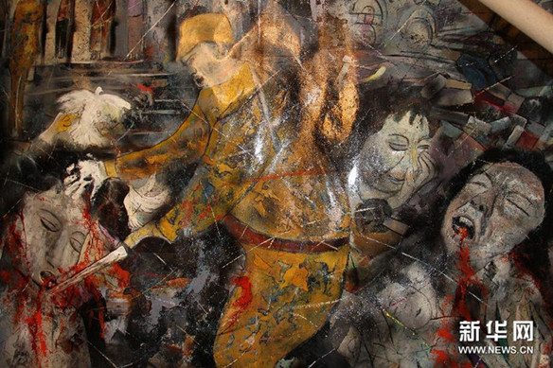
Doc. 8

- Point out the first five things you notice in this photo
- What is the author trying to show in this painting?
- Does this painting do a good job depicting the Nanking Massacre?

