Social Studies Mini-DBQ:
“Should the US have entered World War II by 1940?”
Objective: I can use documents to write a persuasive essay responding to the prompt, “Should the U.S. have entered WWII by 1940?”.
Instructions: Read each document and answer the questions. Write a short essay which includes an introductory paragraph and 1 body paragraph that answers the prompt above. Include all of the following:
1st Paragraph
- Topic sentence
- argument
2nd paragraph
- Main arguments
- Evidence from at least 3 of the sources to support your arguments.

DOCUMENT A
From F. Tillman, "All Captives Slain.'' The New York Times. 18 December 1937, pp. 1, 10.
The Nanking Massacre, 1937
In December of 1937, the Japanese Imperial Army marched into China's capital city of Nanking and proceeded to murder 300,000 out of 600,000 civilians and soldiers in the city. The six weeks of carnage would become known as the Rape of Nanking and represented the single worst atrocity during the World War II era in either the European or Pacific theaters of war.
The killing of civilians was widespread. Foreigners who traveled widely through the city Wednesday found civilian dead on every street. Some of the victims were aged men, women and children.
Policemen and firemen were special objects of attack. Many victims were bayoneted and some of the wounds were barbarously cruel.
Any person who ran because of fear or excitement was likely to be killed on the spot as was any one caught by roving patrols in streets or alleys after dark…
The mass executions of war prisoners added to the horrors the Japanese brought to Nanking. After killing the Chinese soldiers who threw down their arms and surrendered, the Japanese combed the city for men in civilian garb who were suspected of being former soldiers.
In one building in the refugee zone 400 men were seized. They were marched off, tied in batches of fifty, between lines of riflemen and machine gunners, to the execution ground…
The capture of Hsiakwan Gate by the Japanese was accompanied by the mass killing of the defenders, who were piled up among the sandbags, forming a mound six feet high. Late Wednesday the Japanese had not removed the dead, and two days of heavy military traffic had been passing through, grinding over the remains of men, dogs and horses.
The Japanese appear to want the horrors to remain as long as possible, to impress on the Chinese the terrible results of resisting Japan.
Questions
- Provide two examples of what Japanese soldiers did to Chinese citizens in Nanking.

- Explain how the US should have responded to the Nanking Massacre. For example, should America have sent the military to Asia to stop the massacre, should President Roosevelt have held diplomatic meetings with the leaders of Japan and China, or should the US have done nothing? Why do you say so?

DOCUMENT B
Roosevelt, Franklin D. “Quarantine Speech.” Chicago, IL. 5 October 1937.
President Franklin D. Roosevelt’s Quarantine Speech, October 5, 1937
It is my determination to pursue a policy of peace. It is my determination to adopt every practicable measure to avoid involvement in war. It ought to be inconceivable that in this modern era, and in the face of experience, any nation could be so foolish and ruthless as to run the risk of plunging the whole world into war by invading and violating, in contravention of solemn treaties, the territory of other nations that have done them no real harm and are too weak to protect themselves adequately. Yet the peace of the world and the welfare and security of every nation, including our own, is today being threatened by that very thing…
War is a contagion [disease], whether it be declared or undeclared. It can engulf states and peoples remote from the original scene of hostilities. We are determined to keep out of war, yet we cannot insure ourselves against the disastrous effects of war and the dangers of involvement. We are adopting such measures as will minimize our risk of involvement, but we cannot have complete protection in a world of disorder in which confidence and security have broken down…
America hates war. America hopes for peace. Therefore, America actively engages in the search for peace.
Questions
- President Roosevelt said that he wants to “avoid involvement in war,” yet “we cannot insure ourselves against the disastrous effects of war and the dangers of involvement.” Do you think that, in 1937, he could have predicted the US declaring war by 1941? Why do you think so?

- If you believe that the US should have entered World War II by 1940, explain how you can use this speech to support your opinion. If you think the US should have remained neutral, explain how you can use this speech to support your opinion.

DOCUMENT C
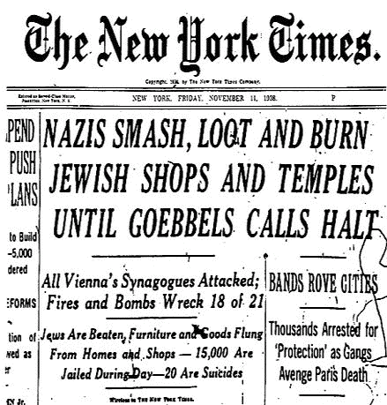
- How would seeing this headline have made you feel if you saw it in America in 1938? Why?

- Do you think America has the responsibility to get involved in other countries when the government attacks people in its borders? Why or why not?
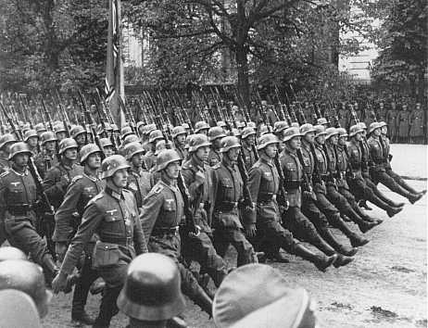
DOCUMENT D

German troops parade through Warsaw after the surrender of Poland. Warsaw, Poland, September 28-30, 1939.
On September 1, 1939, Germany invaded Poland. The Polish army was defeated within weeks of the invasion. From East Prussia and Germany in the north and Silesia and Slovakia in the south, German units, with more than 2,000 tanks and over 1,000 planes, broke through Polish defenses along the border and advanced on Warsaw in a massive encirclement attack. After heavy shelling and bombing, Warsaw surrendered to the Germans on September 27, 1939. Britain and France, standing by their guarantee of Poland's border, had declared war on Germany on September 3, 1939. The Soviet Union invaded eastern Poland on September 17, 1939.
- What emotions would you feel if you were Polish, watching these German soldiers marching through your country? How would it be different if you were an American seeing this image in a newspaper?
- How do this image and the fact that Germany invaded Poland influence your opinion on whether the US should have entered World War II by 1940? Why?

