After viewing the documents and anwsering the questions, respond to the following prompt: What was the cause of the U.S. entering WWI? (Use evidence from 2 documents to suport your anwser. 6-8 sentences)
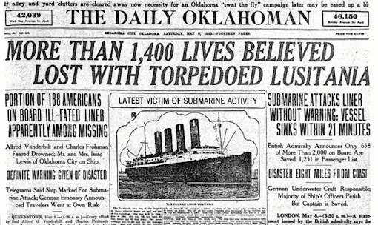
DOCUMENT 1
- Describe the event this newspaper is reporting?

This newspaper is from May 7th 1915

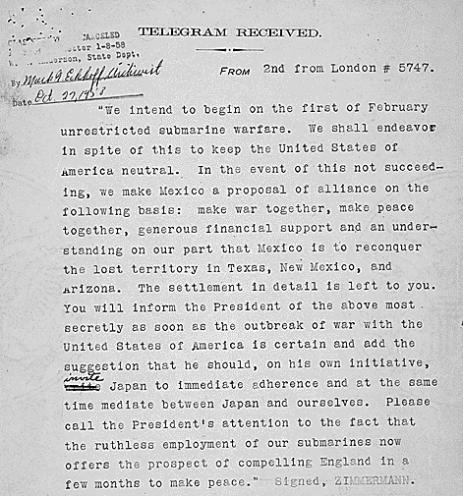
DOCUMENT 2
- Explain why intercepting this message upset the U.S.A (use evidence from the text)
- How does this “Zimmerman Note” relate to the sinking of the Lusitania?
- Use context clues and Document 1 to define “Unrestricted Submarine Warfare”
This note was intercepted in January of 1917

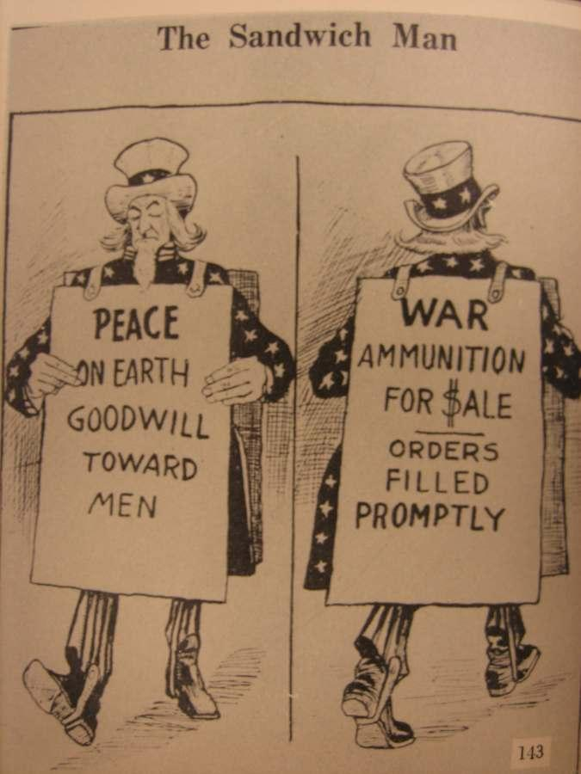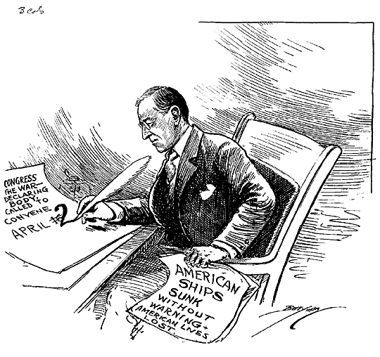
DOCUMENT 4
- According to this cartoonist, what is the reason for America joining WWI?
The U.S. Declares war on Germany April 6, 1917
DOCUMENT 3
- What is the inconsistency that the author is pointing out?
- Who do you believe that the U.S. is selling weapons to? (use your knowledge and other documents to think through this)
- Before declaring war, was the U.S. completely neural?

Cartoon from 1917

