Mao Zedong and The Cultural Revolution: all you need to know about China's political convulsion
Fifty years ago one of the bloodiest eras in Chinese history began, in which as many as two million people died. But who started it and what was it for?
Tom Phillips in Beijing

What was it and when did it begin?
The Great Communist Cultural Revolution was a decade-long period of political and social chaos caused by Mao Zedong’s bid to use the Chinese masses to reassert his control over the Communist party.
Its bewildering complexity and almost unfathomable brutality was such that to this day historians struggle to make sense of everything that occurred during the period.
However, Mao’s decision to launch the “revolution” in May 1966 is now widely interpreted as an attempt to destroy his enemies by unleashing the people on the party and urging them to purify its ranks.
When the mass mobilization kicked off party newspapers depicted it as a struggle that would inject new life into the socialist cause. “Like the red sun rising in the east, the unprecedented Great Proletarian Cultural Revolution is illuminating the land with its brilliant rays,” one editorial read.
In fact, the Cultural Revolution crippled the economy, ruined millions of lives and thrust China into 10 years of turmoil, bloodshed, hunger and stagnation. Gangs of students and Red Guards attacked people wearing “bourgeois clothes” on the street, “imperialist” signs were torn down and intellectuals and party officials were murdered or driven to suicide.
After violence had run its bloody course, the country’s rulers conceded it had been a catastrophe that had brought nothing but “grave disorder, damage and retrogression”.

Whose idea was it and what was the aim?
The Cultural Revolution was the brainchild of China’s leader Mao Zedong. Seventeen years after his troops seized power, Mao saw his latest political campaign as a way of reinvigorating the communist revolution by strengthening ideology and weeding out opponents.
“Our objective is to struggle against and crush those persons in authority who are taking the capitalist road... so as to facilitate the consolidation and development of the socialist system,” one early directive stated.
But it was also an attempt by the dictator, whose authority had been badly hit by the calamitous Great Famine of the 1950s, to reassert control over the party by obliterating enemies, real or imagined.
“It was a power struggle waged behind the smokescreen of a fictitious mass movement.”
Schools and universities were closed and churches, shrines, libraries, shops and private homes ransacked or destroyed as the assault on old traditions began.
Party officials, teachers and intellectuals also found themselves in the cross-hairs: they were publicly humiliated, beaten and in some cases murdered or driven to suicide after vicious “struggle sessions”. Blood flowed as Mao ordered security forces not to interfere in these events. Nearly 1,800 people lost their lives in Beijing in August and September 1966 alone.

What happened next?
After the initial explosion of “red terror”, the chaos spread rapidly. Workers joined the fray and China was plunged into what historians describe as a state of virtual civil war, with rival factions battling it out in cities across the country.
By late 1968 Mao realized his revolution had spiraled out of control. In a bid to rein in the violence he issued instructions to send millions of urban youth down to the countryside for “re-education”.
He also ordered the army to restore order, effectively transforming China into a military dictatorship, which lasted until about 1971. As the army fought to bring the situation under control, the death toll soared.

How many victims were there?
Historians believe somewhere around two million people lost their lives as a result of the Cultural Revolution. Perhaps the worst affected region was the southern province of Guangxi where there were reports of mass killings and even cannibalism.
Appalling acts of barbarity also occurred in Inner Mongolia where authorities unleashed a vicious campaign of torture against supposed separatists. The government was responsible for most of the bloodshed

What was the Little Red Book?
The Cultural Revolution’s official handbook was the Little Red Book, a pocket-sized collection of quotations from Mao that offered a design for chinese life.
“Be resolute, fear no sacrifice, and surmount every difficulty to win victory!” read one famous counsel.
At the height of the Cultural Revolution, Little Red Book reading sessions were held on public buses and even in the skies above China, as air hostesses preached Mao’s words of wisdom to their passengers. During the 1960s, the Little Red Book is said to have been the most printed book on earth, with more than a billion copies printed.
Who else did Mao Zedong Kill?
Before the Cultural Revolution China experienced The “Great Famine”. This was caused by the “Great Leap Forward” that took place in 1958. The Great Leap Forward was Mao’s attempt to modernize China’s economy so that by 1988, China would have an economy that rivalled America.
The Great Leap Forward planned to develop agriculture and industry, and so Mao organized China into a series of communes. People in a commune gave up their ownership of tools, animals etc. so that everything was owned by the commune. People now worked for the commune and not for themselves. The life of an individual was controlled by the commune. Schools and nurseries were provided by the communes so that all adults could work.
Mao had introduced the Great Leap Forward with the phrase “it is possible to accomplish any task whatsoever.” By the end of 1958, it seemed as if his claim was true.
However, in 1959, things started to go wrong. Party officials would order the impossible and commune leaders could be charged with being a “bourgeois reactionary” if he complained. Such a charge would lead to prison. The Government controlled factories and farms failed. Many historians estimate that as many as 50 million people died of starvation as a result of the government controlled “Great Leap Forward”
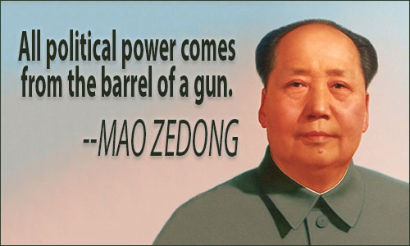
Questions
- Explain and describe the “Cultural Revolution” in China

- What was Mao Zedong’s purpose in starting this “Cultural Revolution”?

- Based on this text, argue whether the “Cultural Revolution” more benefited the people of China, or their leader Mao Zedong. (Use text as evidence)

- Does this author appear to approve of the leadership of Mao Zedong? (use the text to support your response

- How did Mao’s “Little Red Book” help him maintain control over China?
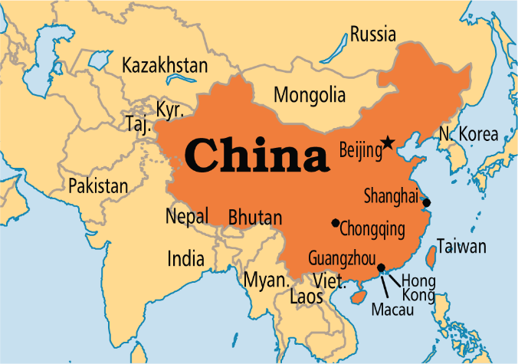
- Does Mao Zedong’s China fit the profile of a Totalitarian society? Support your answer

- What was the “Great Leap Forward”?

