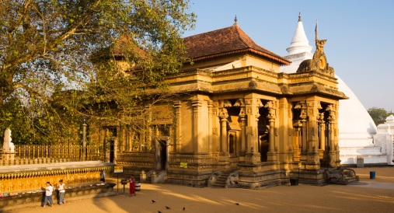
Maha Vihara, Sri Lanka

SRI LANKA

Sri Lanka, only forty-five miles from the southern tip of India, has had a thriving Buddhist culture for more than 2,000 years. According to tradition, the religion was introduced in the mid-third century B.C.E. by missionaries sent by Ashoka (reigned ca. 272 – 231 B.C.E.), India's first great Buddhist king. The missionaries were led by Mahinda, who was possibly the son or brother of Ashoka. Sri Lanka's king, converted to Buddhism and the country's earliest monastic complex, the Mahavihara at Anuradhapura, was founded circa 236 B.C.E..
Around this time, a cutting from the bodhi tree under which Buddha achieved enlightenment was brought from India to Sri Lanka and planted at the Mahavihara; the tree (or its descendent) still flourishes and is the most popular pilgrimage objective in Sri Lanka. Worship of the bodhi tree subsequently became an important part of Sri Lankan worship, and a bodhi tree shrine was established in every monastery. Each consists of seated images of the Buddha placed around the tree facing the four cardinal directions. Unlike Indian representations of the Buddha seated under the bodhi tree, in Sri Lankan images, the Buddha holds his hands in the gesture of meditation.

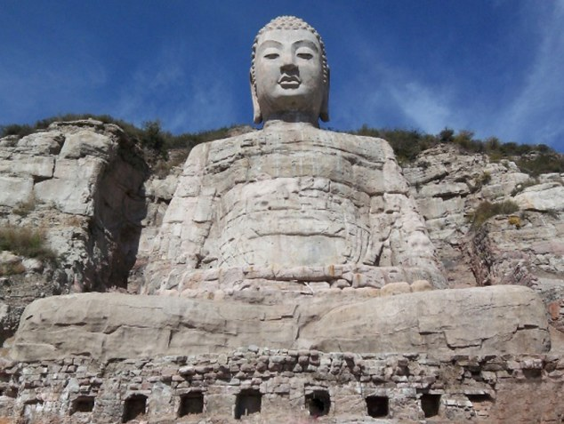
Mengshan Buddha, China
CHINA
The transmission of Buddhism from India to China paralleled an active trade between the two cultures. Most overland trade moved along routes that ran from, depending on the period, either Xi'an or Luoyang in central China, then along either the northern or southern route around the infamous Taklamakan Desert, to routes that headed south from Kashgar and some of the central Asian oasis cities to India via Pakistan, Kashmir, and Nepal. Although there is more literary evidence describing passage along the overland routes than the maritime ones, Chinese archeologists have discovered in Guangzhou (Canton) the site of a boatyard that was in operation during the Qin and Han dynasties (3rd – 1st century B.C.E.) where seagoing vessels were built.
Buddhism reached China by the first century C.E., and afterward a constant influx of Buddhist missionaries, manuscripts, and images traveled from India to China via the overland and maritime trade routes. The religion was often initially absorbed into existing religious practices before believers became converted to its new moral code, but it was eventually adopted in all levels of Chinese society.

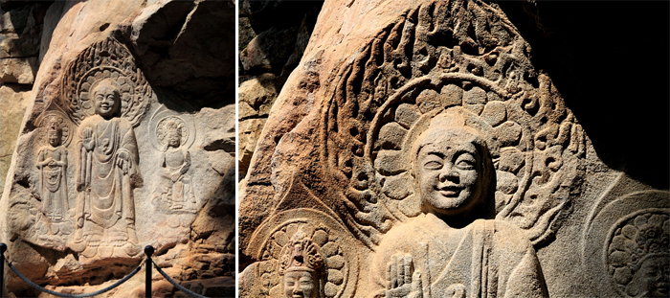
Rock Carved Smiling Buddha, Korea

Korea
Mahayana Buddhism was introduced to the Korean peninsula from China in the fourth century C.E. As in many countries that adopted Buddhism, the religion was first practiced and supported by elites, the royal courts and the aristocracy, but gradually it was adopted by all levels of society. By the late sixth century, Korean monks were traveling along the trade routes to China and even to India to receive training. They returned home bearing texts and images that played a decisive role in the formation of Korean culture and art. Buddhism flourished until the Choson Dynasty (1392 – 1910), when Neo-Confucianism became the state ideology. Buddhism, however, remained a spiritual force in Korean society, and private devotional objects and works for monasteries and temples continued to be made throughout the centuries.

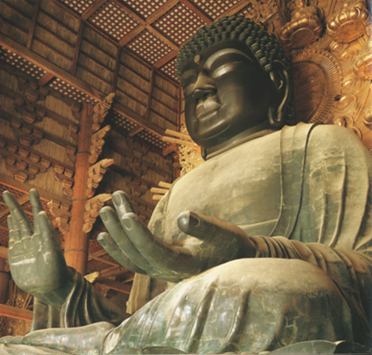
Roshana Buddha in Todai-ji Hall, Japan

Japan
A major, long-established East Asian route of trade and influence ran from northern China down the Korean peninsula and across the Korea Strait to Japan. Traveling along this route, Mahayana Buddhism was introduced into Japan from Korea in the sixth century (traditionally, in either 538 or 552), as part of a diplomatic mission that included gifts. As in Korea, the religion had a lasting effect on the native culture; today, Buddhism is the dominant religion in Japan. As Buddhism prospered there, related arts also flourished. By the seventh century, when the religion was firmly established, Japan had dozens of temple complexes, various orders of priests and nuns, and a body of skilled artisans to craft the icons and other accoutrements (accessories) of faith needed. During the eighth century (Nara period, 710 – 94), Japan was part of an international trading network that linked it with such distant countries as India and Iran, although the strongest cultural and artistic influences still came from China and Korea Japan's cosmopolitan nature at this time is illustrated by the eye-opening ceremony in 752 of a large bronze image of Roshana (Mahavairocana), the supreme Buddha. The statue was housed in the main hall of Todai-ji in Nara. The hall was built for the statue and is still the world's largest wooden structure, the Buddha's eyes were painted in by an Indian monk, an event that was witnessed by roughly ten thousand priests and numerous foreign visitors.

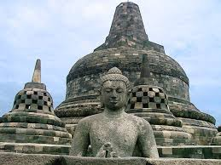
Borobudur Stupa, Java

Java (Indonesia)
Buddhism flourished in many areas of Southeast Asia, and the maritime empire of Shrivijaya played a crucial role in the cross-pollination of Buddhist culture in Asia. This wealthy kingdom, which was the dominant force in the region between the seventh and eleventh centuries, controlled large parts of southern Thailand, Malaysia, and the present-day Indonesian islands of Sumatra and Java. The Borobudur complex was constructed in the 9th century. Until 1025, the trading empire of Shrivijaya also controlled the Strait of Malacca, the strategic sea passage between the Bay of Bengal and the Gulf of Thailand. Shrivijaya was therefore a key intermediary between India and China and Buddhist scholars from both countries often spent years studying in Shrivijaya's famed monasteries.

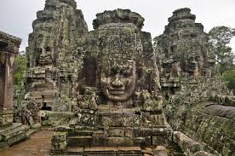
Angkor Wat, Cambodia
Cambodia
The earliest known Buddha images, which date from the sixth century, are linked to the Buddhist centers of southeastern India. However, after the seventh century, there are no clear indications of Indian influence on Cambodian art, in contrast to the Buddhist art produced in the other regions of Southeast Asia, which was often influenced by various streams of Indian art. Unlike the region's most common representations of buddhas, which are unadorned, buddhas produced under the Khmer empire, which ruled Cambodia from the ninth to thirteenth centuy, were often crowned and bejeweled. The complex at Angkor Wat was built in 1150 C.E. During the twelfth and thirteenth centuries, Khmer kings attempted to stress their close relationship to, if not their complete identification with, the Buddha. Thus, the crowns and jewelry adorning these images are similar to those worn by the earthly kings.

