World Religions/Belief system quiz
Use the following Passage to answer question #1
There is no existence for that which is unreal; there is no non-existence for that which is real. And the correct conclusion about both is perceived by those who perceive the truth. Know that to be indestructible which pervades all this; the destruction of that inexhaustible principle none can bring about. These bodies that pertain to the embodied self which is eternal, indestructible, and indefinable, are said to be perishable; therefore do engage in battle, O descendant of Bharata! He who thinks it to be the killer and he who thinks it to be killed, both know nothing. The self kills not, and the self is not killed. It is not born, nor does it ever die, nor, having existed, does it exist no more. Unborn, everlasting, unchangeable, and primeval, the self is not killed when the body is killed. From the Bhagavad Gita
- The above passage illustrates which of the following concepts?
- The Hindu concept of reincarnation
- The Buddhist focus on the eightfold path as a way to enlightenment
- The Confucian value of harmonious familial relationships
- The Hindu rejection of the idea of a “just war”

Use the following passage to answer question # 2
Hardly ten men of true integrity and good faith can be found today, and yet the offices of the state number in the hundreds. If they must be filled by men of integrity and good faith, then there will never be enough men to go around; and if the offices are left unfilled, then those whose business it is to govern will dwindle in numbers while disorderly men increase. Therefore the way of the enlightened ruler is to unify the laws instead of seeking for wise men, to lay down firm policies instead of longing for men of good faith. Hence his laws never fail him, and there is no felony or deceit among his officials. …
Selections from the Han Feizi
- The author of the above passage is most closely identified with the belief system known as
- Confucianism
- Manicheism
- Neo-confucianism
- Legalism

Use the following passage to answer questions #’s 3-4

1. With outspread hands in petition for that help, O Mazda, I will pray for the works of the holy spirit, O thou the Right, whereby I may please the will of Good Thought and the Ox-Soul.

4. I who have set my heart on watching over the soul, in union with Good Thought, and as knowing the rewards of Mazda Ahura for our works, will, while I have power and strength, teach men to seek after Right.

5. O Asha, shall I see thee and Good Thought, as one that knows? Shall I see the throne of the mightiest Ahura and the following of Mazda? Through this world of promise on our tongue will we turn the robber horde unto the Greatest.

9. With the bounties, O Ahura, may we never provoke your wrath, O Mazda and Right and Best Thought, we who have ben eager in bringing you songs of praise. Ye are they that are the mightiest to advance desire and the Dominion of Blessings.

10. The wise whom thou knowest as worthy, for their right doing and their good thought, for them do thou fulfill their longing for attainment. For I know words of prayer are effective with Ye, which tend to a good object.

11. I would thereby preserve Right and Good Thought forevermore, that I may instruct do thou teach me O Mazda Ahura, from they spirit by thy mouth how it will be with the First Life.
Source: The Avesta: Ahunavaita Gatha. The Gathas are sacred hymns of the Zoroastrian religion. They are believed to have been written by the founder of the religion in Persia between 1500 – 1200 BCE.

3. The excerpt above best provides evidence of which of the following?
(A) Early civilizations formed beliefs of a spiritual realm that interacted with the physical realm.
(B) Early civilizations concerned themselves only with the physical world and formed beliefs about how to behave that were largely void of any connection with a spiritual realm.
(C) All early spiritual beliefs and religious ideologies were monotheistic
(D) Systems of religious ideologies provided ridged gender roles that tended to favor men in the public realm.

4. Which of the following can be said about the above text?
(A) Early societies were particularly suspicious of religions that dictated strict regulations on human behavior.
(B) Avesta: Ahunavaita illustrates the importance of the connection between the spiritual realm and the way in which individuals live their lives.
(C) Zoroastrianism was a religion that forbid the lifestyle of a merchant
(D). Early religious beliefs lacked mechanisms to control human behavior.

Use the following passage to answer question # 5
The master said, “In serving his father and mother a man may gently disagree with them. But if he sees that he has failed to change their opinion, he should resume an attitude of humility and not thwart them; he must accept and respect their wishes, for this is the proper role of the son.”
5. Which of the following principles of Confucianism is evident in the piece?
  - filial piety
  - understanding that life is suffering
  - submitting to governmental authority
  - seeking balance with nature

Line up each passage with the corresponding belief system.
6. “Therefore the sage, in the exercise of his government, empties their minds, fills their bellies, weakens their wills and strengthens their bones. He constantly (tries to) keep them without knowledge and without desire, and where there are those who have knowledge, to keep them from presuming to act (on it). When there is this abstinence from action, good order is universal.”
(A)Buddhism
(B)Daoism
(C)Christianity
(D)Hinduism

7. “Life is suffering, suffering is caused by desire, eliminating desire ends suffering, the way to end suffering is to follow the middle path or the eightfold path.”
- Buddhism
- Daoism
- Christianity
- Hinduism

8. “It is a many faceted religion, but the goal is Moksha and a liberation of samsara. Through devotion, prayer, karma and an adherence to jati, this can be achieved.”
- Buddhism
- Daoism
- Christianity
- Hinduism

9. “Do not judge and you will not be judged. Do not condemn and you will not be condemned. Forgive and you will be forgiven.”
- Buddhism
- Daoism
- Christianity
- Hinduism

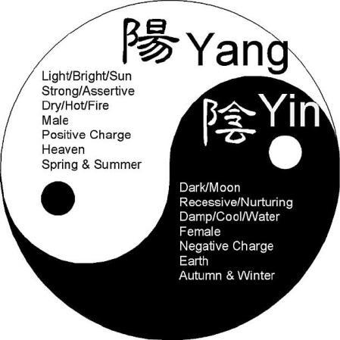
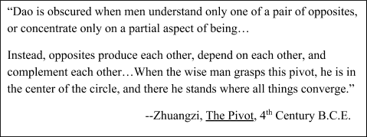
10. According Zhuangzi, where in the “Yin-Yang Symbol” should wise men seek understanding?

(A) In the “light” and male part of the circle
(B) In the “dark” and female part of the circle
(C) In the perfect center of the circle
(D) In the outside of the circle

