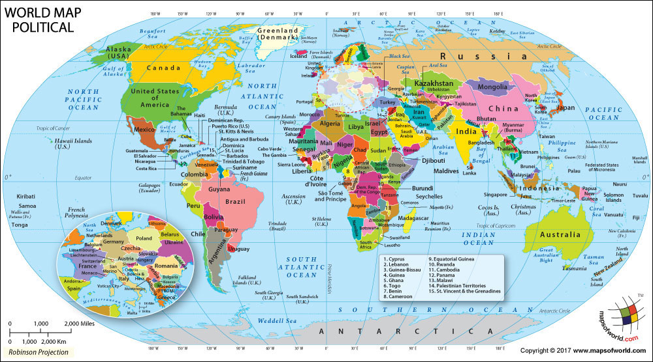
Globalization

- Definition of globalization (Use internet):
NPR Makes a T-Shirt:
After you watch each clip, answer the following:
Part 2:
- Explain the factors that allow the U.S. to grow cotton so cheaply?
- How many shirts could be produced from the one farm depicted in the film?
Part 3:
- In what countries is the American cotton spun?
- In what country is the American cotton woven into fabric?
Part 4:
- In which nation was the women’s t-shirt made? The mens?
- How much does a worker in Bangladesh make?
- Why do so many women work in the garment industry when it provides long hours, little pay, and poor working conditions?
Part 5:
- Explain the process by which a shirt makes it form colombia to the U.S.
- Due to the efficiency of this technology, how much does it cost to transport each shirt?
- Based on this video series, what do you think might be the pros and cons of globalization?
- Why is free trade promoted by some? Why are some critical?
- How do multi-national companies benefit from globalization?
- Brainstorm with your partner: What are some multinational corporations you can think of?

