Primary Sources: European Impact on Native Cultures

Case Study: The Conquest of the Aztecs
Source 1: Taxes in the Aztec Empire

“With a core population recently estimated at 5 to 6 million people, the Aztec Empire was a loosely structured and unstable conquest state that witnessed frequent rebellions by its subject peoples. Conquered peoples and cities were required to regularly deliver to their Aztec rulers impressive quantities of textiles and clothing, military supplies, jewelry, and other luxuries, various foodstuffs, animal products, building materials, rubber balls, paper, and more. The process was overseen by local imperial tribute collectors, who sent the required goods on to Tenochtitlan, a metropolis of 150,000 to 200,000 people, where they were meticulously recorded.”
Secondary Source: “The Aztec Empire” in Ways of the World by Robert W. Strayer; p. 590

1. What can you infer about life in the Aztec empire from the first sentence of the source above?
2. Describe the relationship between the Aztecs and their neighbors.

Source 2: Aztec Religion Source 3: Cortes on Sacrifice
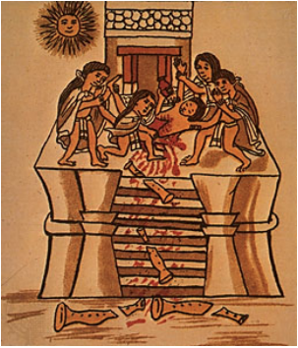
“…Each day before beginning any sort of work they burn incense in these temples and sometimes sacrifice their own persons, some cutting their tongues, others their ears, while there are some who stab their bodies with knives. All the blood which flows from them they offer to those idols, sprinkling it in all parts of the temple, or sometimes throwing it into the air…”
Hernan Cortes. Letters From Mexico. trans. A. R. Pagden, ed. A. R. Pagden

3. What can you tell about Aztec religion based on Sources 2 and 3?

Source 4: The Aztec King and Cortés Meet (Modified)

Then Montezuma stood up [and] addressed Cortés in these words: “Our lord, you are weary. The journey has tired you, but now you have arrived on the earth. You have come to your city, Mexico. You have come here to sit on your throne, to sit under its canopy . . .
Your return was foretold by the kings who governed your city, and now it has taken place. You have come back to us. . . Rest now, and take possession of your royal houses. Welcome to your land, my lords!”
Cortés replied in his strange and savage tongue, speaking first to [his translator]: “Tell Montezuma that we are his friends. There is nothing to fear. We have wanted to see him for a long time, and now we have seen his face and heard his words. Tell him that we love him well and that our hearts are contented . . .”
Aztec account from 1519. From The Broken Spears: The Aztec Account of the conquest of Mexico

4. Describe the meeting of Cortés and Montezuma? Who/what does Montezuma seem to think Cortés is?

Source 4: Spanish Massacre
Two days after the meeting of Montezuma and Cortés…

“When the dance was loveliest and when song was linked to song, the Spaniards were seized with an urge to kill the celebrants. They all ran forward, armed as if for battle. They closed the entrances and passageways...then [they] rushed into the Sacred Patio to slaughter the inhabitants...they attacked the man who was drumming and cut off his arms. Then they cut off his head, and it rolled across the floor. They attacked all the celebrants stabbing them, spearing them, striking them with swords...others they beheaded...or split their heads to pieces...The blood of the warriors flowed like water and gathered into pools...They invaded every room, hunting and killing...”
Primary Source: Aztec account of the massacre at the temple in May 1520; Florentine codex

5. What do the Spanish do during the celebration? How does this differ from what Cortés said when he met Montezuma?

Source 5: Illustration from the Florentine Codex Source 6: Smallpox Plague
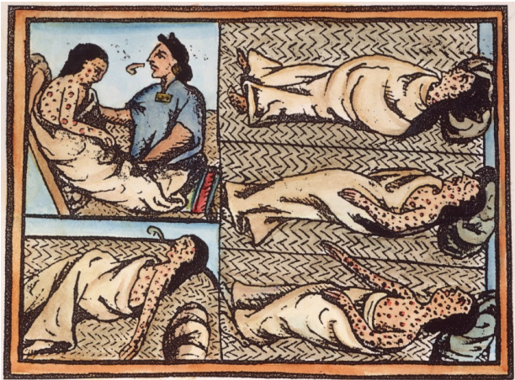
“When Hernando Cortés was captain and governor… there was in one of his ships a negro stricken with smallpox, a disease which had never been seen here. At this time [South America] was extremely full of people, and when the smallpox began to attack the Indians it became so great a [disease] among them… that in most provinces more than half the population died… The Indians… were very much in the habit of bathing frequently, whether well or ill, and continued to do so even when suffering from smallpox, they died in heaps, like bedbugs. Many others died of starvation, because, as they were all taken sick at once, they could not care for each other, nor was there anyone to give them bread or anything else. . .This disease was called by the Indians ‘the great leprosy’ because the victims were so covered with pustules [pimples] that they looked like lepers. Even today one can see obvious evidences of it in some individuals
Elizabeth A. Foster, ed., Motolinía’s History of the Indians of New Spain, Greenwood Press, 1977

6. Using evidence from sources 5 and 6, describe dangers that faced indigenous population after the Spanish arrival.

7. What effect would these plagues have on the Aztec ability to resist the Spanish invasion?

Culminating task: respond to the following prompt in a paragraph.
Prompt: “Explain why the Spanish were able to so easily defeat the Aztecs upon landing in America.”

