**Historical Context:**

*The French Revolution of 1789 had many long-range causes.* ***Political, social, and economic structures*** *in France contributed to public discontent felt by many French people-especially those of the* ***Third Estate****. The ideas of the* ***philosophers of the Enlightenment*** *brought new ideas about the role of the monarch and powers guaranteed to France’s citizens. Finally, the American Revolution showed the French that a country could be successful without a king.*

**Directions:** Answer the questions which follow each document to help you as you go.

**Seconday Source** **- Document 1**: Friedman & Foner, A Genetic Approach to Modern European History, College Entrance Book Co., 1938

“. . . Powers of the king.—The King, Louis XVI, was absolute. He ruled by the DIVINE RIGHT theory which held that he had received his power to govern from GOD and was therefore responsible to GOD alone. He appointed all civil officials and military officers. He made and enforced the laws. He could declare war and make peace. He levied taxes and spent the people’s money as he saw fit. He controlled the expression of thought by a strict censorship of speech and press. By means of *lettres de cachet* (sealed letters which were really blank warrants for arrest) he could arbitrarily imprison anyone without trial for an indefinite period. He lived in his magnificent palace at Versailles, completely oblivious to the rising tide of popular discontent. . . .”

**1: Why might the people of France be angry with King Louis XVI?**

**Secondary Source - Document 2:**  This diagram illustrates France’s social structures in 1789 – called the OLD REGIME – the social ladder consisted of THREE ESTATES.



**2: What unfair conditions existed in pre-revolutionary France?**

**Primary Source – Document 3**

That the king be forced to reform the abuses and tyranny of the crown. That every tax.... Be granted [by the Estates General] only for a limited time. That the taille [a tax on land] be borne equally by all classes.... The meetings of the Estates General.... Shall be scheduled for definite times.... In order to assure the third estate the influence it deserves because of its numbers... its votes in the assembly should be taken by head..

**3: What three changes did the third estate demand be made in the French Government?**

**Primary Source - Document 4:**  Excerpt from: Miss Betham-Edwards, ed., Arthur Young’s Travels in France During the Years 1787, 1788, and 1789

*“September 5, 1788: The poor people seem very poor indeed. The children are terribly ragged.*

*June 10, 1789: The lack of bread is terrible. Stories arrive every moment from the provinces of riots and disturbances, and calling in the military, to preserve the peace of the markets….The price of bread has risen above people’s ability to pay. This causes great misery.*

*July 12, 1789: Walking up a long hill, to ease my mare, I was joined by a poor woman, who complained of the times, and that it was a sad country; demanding her reasons, she said her husband had but a small plot of land, one cow, and a poor little horse, yet they had to pay a tax of 42 pounds of wheat, and three chickens, to one noble and 168 pounds of oats, one chicken and 1 sou [small unit of money] to another...the taxes and laws are crushing us.*

*This woman, at no great distance, might have been taken for sixty or seventy, her figure was so bent, and her face so wrinkled and hardened by labor, — but she said she was only twenty-eight.”*

**4: List three observations this traveler made about the life of the peasant in France between 1787 and 1789.**

**5: What do these observations show us about the conditions of France during this time?**

**Secondary Source – Documents 5**

The Revolution had been accomplished in the minds of men long before it was translated into fact.... The middle class... was sensitive to their inferior legal position. The Revolution came from them-the middle class. The working classes were incapable of starting or controlling the Revolution. They were just beginning to learn to read

**6: Who does this author argue is responsible for starting and leading the French Revolution?**

**Secondary Source - Document 6:** From *Lectures on the French Revolution* by Sir John Dalberg-Acton, an English historian, politician, and writer.

*“The condition of France alone did not bring about the overthrow of the monarchy… for the suffering of the people was not greater than they had been before. The ideas of the [Enlightenment philosophers] were not directly responsible for the outbreak…[but] the spark that changed thought into action was supplied by the Declaration of American independence… The American example caused the Revolution to break out…”*

**7: What did Lord Acton believe caused the French Revolution?**

**Primary Source - Document 7:** Comte D’Antraigues as quoted in an excerpt from Citizens: A Chronicle of the French Revolution.

*“The Third Estate is the People and the People is the foundation of the State; it is in fact the State itself; Nobles and clergy are merely political categories while according to the unchangeable laws of nature the People is everything. Everything should be subordinated (inferior) to it… It is in the People that all national power resides and for the People that all states exist.”*

**8: What ENLIGHTENMENT IDEA is the Comte D’Antraigues expressing in this quote?**

**Primary Source – Document 8:**

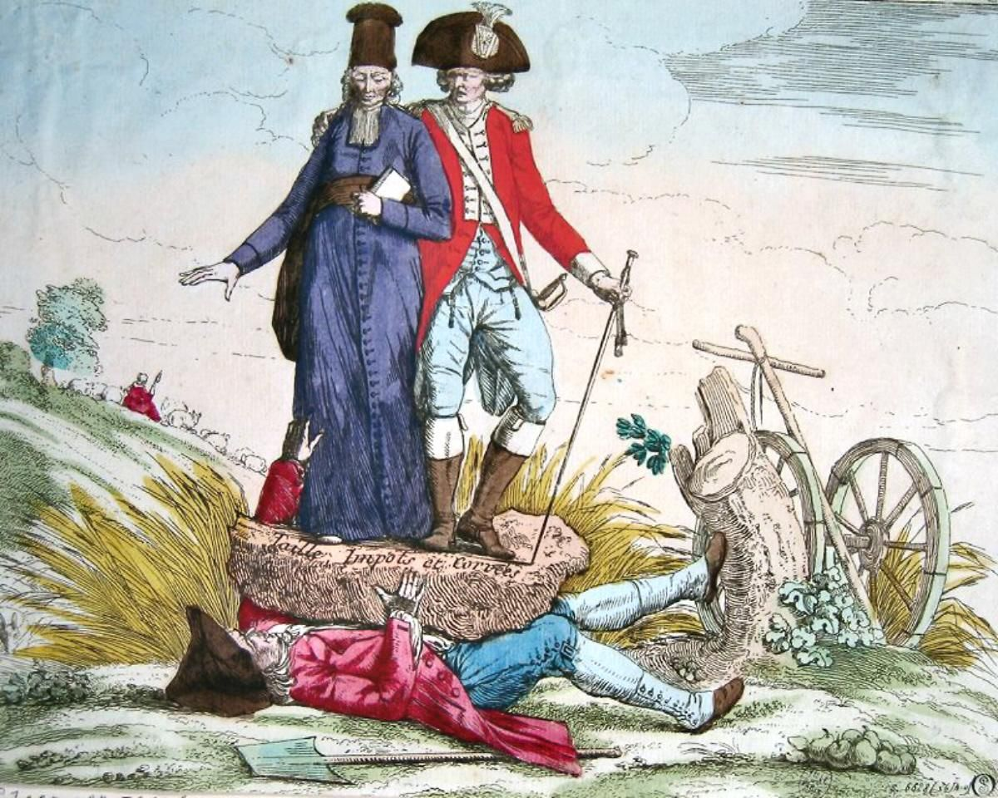

**9: What is this cartoonist saying about the relationship among the three estates in France?**

**Primary Source – Document 9**

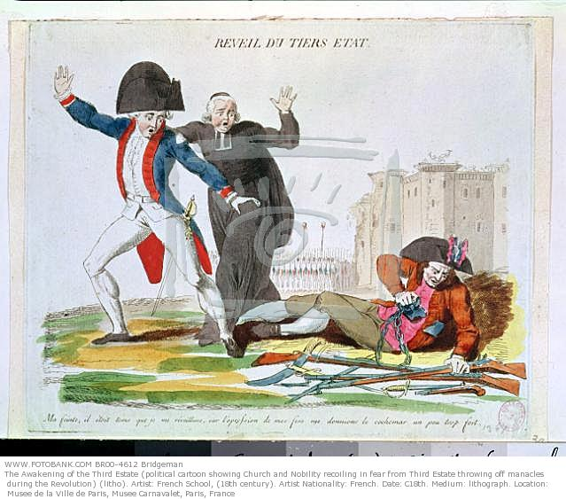

**10: What is this cartoonist saying about the start of the French Revolution?**