PART 1 - SHORT ANSWER
The documents below relate to the bombing of Hiroshima and Nagasaki. Examine each document carefully and then answer the question or questions that follow.
Document 1
"I had then set up a committee of top men and had asked them to study with great care the implications the new weapons might have for us. It was their recommendation that the bomb be used against the enemy as soon as it could be done. They recommended further that it should be used without specific warning... I had realized, of course, that an atomic bomb explosion would inflict damage and casualties beyond imagination. On the other hand, the scientific advisors of the committee reported... that no technical demonstration they might propose, such as over a deserted island, would be likely to bring the war to an end. It had to be used against an enemy target.
The final decision of where and when to use the atomic bomb was up to me. Let there be no mistake about it. I regarded the bomb as a military weapon and never doubted it should be used."
—President Harry S. Truman
- Why did President Truman feel that the atomic bomb had to be used against enemy targets?

Document 2
"The use of this barbarous weapon at Hiroshima and Nagasaki was of no material assistance in our war against Japan. The Japanese were already defeated and ready to surrender...
"In being the first to use it, we . . . adopted an ethical standard common to the barbarians of the Dark Ages. I was not taught to make war in that fashion, and wars cannot be won by destroying women and children."
— Admiral William E. Leahy, President Truman's Chief of Staff, in his memoirs "I Was There"
- Why did Admiral Leahy feel the use of the atomic bomb on Japan was unnecessary?
- Why did Admiral Leahy think the use of the atomic bomb on Hiroshima and Nagasaki was ethically wrong?

Document 3
"The face of war is the face of death; death is an inevitable part of every order that a wartime leader gives. The decision to use the atomic bomb was a decision that brought death to over a hundred thousand Japanese...
"But this deliberate, premeditated destruction was our least abhorrent alternative. The destruction of Hiroshima and Nagasaki put an end to the Japanese war. It stopped the fire raids, and the strangling blockade; it ended the ghastly specter of a clash of great land armies. In this last great action of the Second World War we were given final proof that war is death."
—Secretary of War Henry Stimson
- Why did Stimson think the use of the atomic bomb on Hiroshima and Nagasaki was a terrible thing to do but better than any alternative?

Document 4
"The view where a moment before all had been so bright and sunny was now dark and hazy... What had happened? All over the right side of my body I was bleeding... My private nurse set about examining my wounds without speaking a word. No one spoke... Why was everyone so quiet? The heat finally became too intense to endure... Those who could fled; those who could not perished...
Hiroshima was no longer a city but a burned-over prairie. To the east and to the west everything was flattened. The distant mountains seemed nearer than I could ever remember... How small Hiroshima was with its houses gone."
- Michihiko Hachiya, Hiroshima Diary: The Journal of a Japanese Physician August 6 - September 30, 1945
5) What observations did the doctor make about the effects of the bombing on his city?

Document 5
Images of Nagasaki, 1945
Source: Yamahata photographs © Shogo Yamahata, The Day After the Nagasaki Bombing. The Japan Peace Museum (www.peace-museum.org)
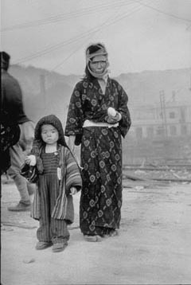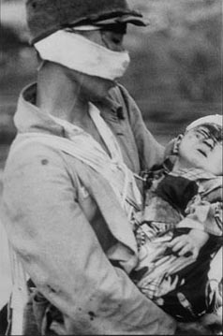

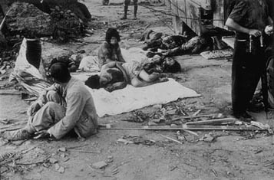

- Describe the effects of the bombing, as seen in these photographs.
PART 2 – Choices
Some Background:
It is late July 1945. Over 400,000 US servicemen have been killed during America’s four years at war. Hitler’s “Thousand Year Reich” was defeated in May 1945 after 12 years. Japan though was still savagely fighting against the oncoming Americans in the Pacific. Japan of course was the country that pulled us directly into this war with their surprise attack on Pearl Harbor, Hawaii in Dec. 1941. President Franklin Roosevelt stated a goal of “unconditional surrender of the axis powers”. At this time, the US was slowly but successfully regaining territory taken early by the Japanese.
In 1944, as the US “island hopped” closer and closer to mainland Japan, the desperate Japanese dispensed a new weapon in the form of the kamikaze. While striking fear into many naval personnel, it did not deter the US’s effort to forge “onward toward Japan!”
In early 1945 at the battle of Okinawa, an island considered part of Japan, casualties were horrifying….about 50% of all US forces that invaded the island were killed or wounded. Bottom line….the closer US forces got to mainland Japan, the more desperately the Japanese fought and prepared their people for the incoming invasion. As an example of this desperation…..the Japanese were training small children how to stab a landing US soldier in the leg with poison spears. In April of 1945, the tragic news of FDR’s death left the nation feeling uncertain that the heir to his office, Vice President Harry S Truman could fill the battle tested Roosevelt’s place.
Truman made a speech meant for the world to hear that the US would not quit the war in the Pacific until Japan surrendered unconditionally. With no formal surrender from Japan coming after the speech, it looked like a full scale invasion of the mainland was needed.
Then while at a conference in Potsdam, Germany, Truman got word that the United States had successfully exploded an atomic bomb back in Los Alamos, NM. Harry S Truman from the small town of Independence Missouri then had a decision to make…..and that decision and a small taste of the consequences of it is now yours!
Your two options:
Order the mainland invasion of Japan, secure it with ground troops to force the surrender of Japan. Estimates from Generals in the Pacific have the number of casualties starting in the 400,000’s to complete this.
Order the dropping of an atomic bomb(s) to force the surrender. Estimates vary, but dropping an atomic bomb on a city will kill somewhere between 15,000 to 75,000 instantly. While a city that makes munitions for the war will be chosen, it cannot be helped that many civilians including children are part of that estimate.
- Your Harry Truman in June 1945……..what will you choose?!?!
Invasion _______ Drop the a-bomb ______
Explain your reasoning in a well written paragraph
NOW WRITE A RESPONSE PARAGRAPH
If you chose invasion, then write a response letter to a woman named Jane who lost her husband and one of her three brothers in the invasion. She wants to know why we had to invade. She states that Japan was already beaten and was no longer a threat. She asks who will support her three year old girl. She is devastated.
If you chose to drop the a-bomb, then write a response letter to a Airi, a woman who lost her entire family, including her husband, her 11 year old son, her 6 year old daughter and her parents, in the bombing of Hiroshima. She was North of the city on the horrific day the world was changed forever. She wants to know how you sleep at night. She sent pictures of her killed family members. She wants to know if this is how America defines liberty and peace. She is devastated.

