Unit 4 Packet
1450 – 1750

NAME : _________________________________________________

Note: Keep this packet until the end of the year so you can study it!

Timeline

Dates | Event | Location(s)
1440s | - Printing Press invented | Europe
1450s | - Portuguese expand trade in Benin, Kongo | West Africa
1453 | - Ottomans overtake Constantinople, ending Byzantine Empire | Modern-day Turkey
1480s | - Height of Aztec Empire | Modern-day Mexico, Belize, Honduras
1483 | - Babur conquered northern India, founded Mughal Empire | India
1492 | - Reconquista completed, Columbus claimed Americas for Spain | Spain, New World
1498 | - Vasco da Gama attacked Calicut | India
1502 | - First African slaves to Americas | Middle Passage
1517 | - Martin Luther posted 95 Theses | Germany
1521 | - Hernan Cortez conquered Aztecs | Modern-day Mexico
1533 | - Francisco Pizarro conquered Inca | South America
1543 | - Copernican proof of heliocentrism published | Europe
1545 | - Discovery of silver at Potosi | Modern-day Bolivia
1570s | - Europeans join spice trade in Asia | Indian Ocean
1588 | - English defeat of Spanish Armada | Off the coast of France
1600 | - Battle of Sekigahara | Japan
1600s | - Charters to British, Dutch, French East India Companies  - Serfdom in Eastern Europe and Russia increases | Europe – Asia  Eastern Europe, Russia
1636 | - Tokugawa Japan’s Act of Seclusion | Japan
1644 | - End of Ming Dynasty/start of Qing Dynasty | China
1683 | - Unsuccessful Ottoman siege of Vienna | Europe
1689 | - Glorious Revolution, English Bill of Rights | England

Chapter 16: The World Economy
Chapter 17: The Transformation of the West, 1450 – 1750
Chapter 18: The Rise of Russia
Chapter 19: Early Latin America
Chapter 20: Africa and the Africans in the Age of the Atlantic Slave Trade
Chapter 21: The Muslim Empires
Chapter 22: Asian Transitions in an Age of Global Change
Key Concept 4.1 Globalizing Networks of Communication and Exchange

- In the context of the new global circulation of goods, there was an intensification of all existing regional patterns of trade that brought prosperity and economic disruption to the merchants and governments in the trading regions of the Indian Ocean, Mediterranean, Sahara, and overland Eurasia.

- European technological developments in cartography and navigation built on previous knowledge developed in the Classical, Islamic, and Asian worlds. All of the following made transoceanic travel possible: production of new tools, innovations in ship designs, and improved understanding of wind/current patterns.

Define cartography: _________________________________________________________________________________

How did this improve travel?
Astrolabe
Caravel

- Remarkable new transoceanic maritime reconnaissance occurred in this period.

- Why was Portugal the first European country to embark on an exploration program?
______________________________________________________________________________________________________________________________________________________________________________________________________________________________________________________________________________________________________
What were 2 reasons that motivated Prince Henry to travel to western Africa?
____________________________________________________________________________________________________________________________________________________________________________________________________

What did the Portuguese do in order to try to create a trading-post empire?
______________________________________________________________________________________________________________________________________________________________________________________________________________________________________________________________________________________________________

(Hint: Use the website “History Haven” to answer the questions above and below! Read the sections under Key Concept 4.1)
- What country sponsored the voyages of Christopher Columbus? _______________________________________

Why were Columbus’ travels so important for the world at the time? (What did they start?)
______________________________________________________________________________________________________________________________________________________________________________________________________________________________________________________________________________________________________

- Northern Atlantic crossings for fishing and settlements continued and spurred European searches for multiple trade routes to Asia

- The new global circulation of goods was facilitated by royal chartered European monopoly companies that took silver from Spanish colonies in the Americas to purchase Asian goods for the Atlantic markets. Regional markets continued to flourish in Afro-Eurasia by using established commercial practices and new transoceanic shipping services developed by European merchants.

- European merchants’ role in Asian trade was characterized mostly by transporting goods from one Asian country to another market in Asia or the Indian Ocean region.

Why were Europeans able to accomplish this role in Asia and the Indian Ocean? (What did they have that was superior?) ___________________________________________________________________________________

- The circulation of what precious metal from the Americas was intimately tied to commercialization and the creation of a global economy? __________________

- Define mercantilism: __________________________________________________________________________
__________________________________________________________________________________________________
__________________________________________________________________________________________________

Joint-stock companies were new methods used by European rulers to control economies and complete in global trade.

How did they control domestic and colonial economies and/or compete in global trade?
Dutch East India Company
British East India Company

- On the map below, label the following locations to show the movement of goods, wealth, free and unfree laborers as part of the Atlantic system: Africa, Americas, Europe.
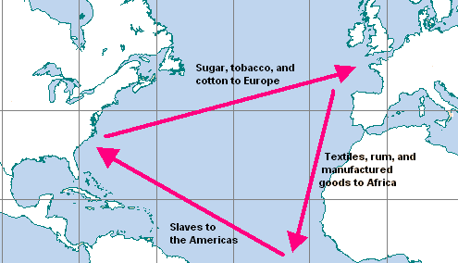

2

1

3

Define ‘indentured servitude’: _________________________________________________________________________
____________________________________________________________________________________________________________________________________________________________________________________________________

- The new connections between the Eastern and Western hemispheres resulted in the Columbian Exchange.

- European colonization of the Americas led to the spread of diseases – including smallpox, measles, and influenza – that were endemic in the Eastern Hemisphere among Amerindian populations and the unintentional transfer of vermin, including mosquitos and rats. Explain how the transfer of diseases and vermin to the Americans from Europeans impacted Amerindian populations:
______________________________________________________________________________________________________________________________________________________________________________________________________________________________________________________________________________________________________

- In the space below, provide examples of staple food crops and cash crops that originated in the Americas but transferred to Europe, Asia, and Africa as part of the colonial exchange. Additionally, for each crop listed, discuss its impact on Afro-Eurasia.

Impact on Afro-Eurasia
Maize
Sugar

What’s the difference between staple crops and cash crops? __________________________________________________
____________________________________________________________________________________________________________________________________________________________________________________________________

- Afro-Eurasian fruit trees, grains, sugar, and domesticated animals were brought by Europeans to the Americas, while other foods were brought by African slaves. In the space below, explain its impact on the Americas.

Impact on the Americas
Horses
Sugar
Cattle

- Populations in Afro-Eurasia benefitted nutritionally from the increased diversity of American food crops.

- European colonization affected the physical environment of the Americas. Explain how European agriculture and settlements caused deforestation and soil depletion in the Americas: ____________________________________
______________________________________________________________________________________________________________________________________________________________________________________________________________________________________________________________________________________________________

- The increase in interactions between newly connected hemispheres and intensification of connections within hemispheres expanded the spread and reform of existing religions and created syncretic belief systems and practices.

Define syncretism: ________________________________________________________________________
__________________________________________________________________________________________________
In the space below, describe TWO examples of syncretic belief systems and practices that resulted from the increase in interactions between newly connected hemispheres and intensification of connections within hemispheres: (Look at History Haven!)

Define Sikhism and how it developed: _________________________________________________________
____________________________________________________________________________________________________________________________________________________________________________________________________
____________________________________________________________________________________________________________________________________________________________________________________________________

Define Sufi and describe its importance to the spread of Islam: _____________________________________
________________________________________________________________________________________________________________________________________________________________________________________________________________________________________________________________________________________________________________________________________________________________________________________________________

- Put the following chain of events in order: Expansion of literacy, merchants’ profits increased and governments collected more taxes, funding for visual and performing arts increased.
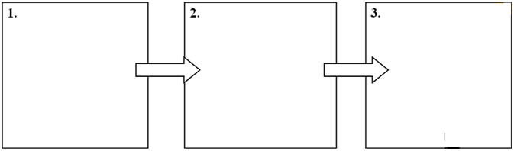

How did expanding literacy impact lower classes?
____________________________________________________________________________________________________________________________________________________________________________________________________

For each of the pieces of literature listed below, identify its name, author, and historical significance:

What playwright is depicted?
Explain his historical significance

Title of the Book | 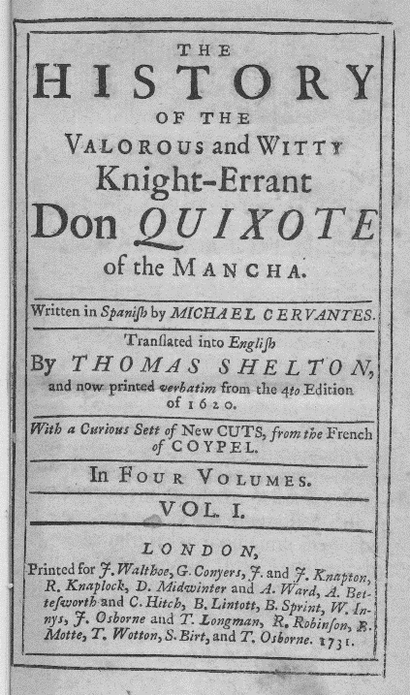
Who was the author?

Explain its historical significance

Key Concept 4.2 New Forms of Social Organization and Modes of Production

- What was the Little Ice Age? How long did it last? _______________________________________________
__________________________________________________________________________________________________
What impact did the Little Ice Age have on agricultural practices and settlement in the Northern Hemisphere?
____________________________________________________________________________________________________________________________________________________________________________________________________
- Traditional peasant agriculture increased and changed, plantations expanded, and demand for labor increased. These changes both fed and responded to growing global demand for raw materials and finished products.

- In the space below, describe TWO examples of the intensification of peasant labor: (Use History Haven!)

Region | Why did peasant labor intensify/increase? | Products Produced
Russian Siberia |  | Fur, grain
Mughal India

- Slavery in Africa continued both the traditional incorporation of slaves into households and the export of slaves to the Mediterranean and Indian Ocean.

- Why did the growth of the plantation economy increase demand for slaves in the Americas?
______________________________________________________________________________________________________________________________________________________________________________________________________________________________________________________________________________________________________
- Colonial economies in the Americas depended on a range of coerced labor. Define the following:

Chattel Slavery
Indentured Servitude
Encomienda and Hacienda Systems

- As social and political elites changed, they also restructured ethnic, racial, and gender hierarchies.

- Imperial conquests and widening global economic opportunities contributed to the formation of new political and economic elites.

Describe how/why Manchus rose to power in China: ________________________________________________
____________________________________________________________________________________________________________________________________________________________________________________________________
- The power of existing political and economic elites fluctuated as they confronted new challenges to their ability to affect the policies of the increasingly powerful monarchs and leaders.

Describe the challenges to the authority of the Daimyo in Japan: _______________________________________
____________________________________________________________________________________________________________________________________________________________________________________________________

- Notable gender and family restructuring that occurred during the time period.

How did the Atlantic Slave Trade affect the demographics of Africa? ___________________________________
____________________________________________________________________________________________________________________________________________________________________________________________________
Describe the practice of “temporary marriage” between European men and Southeast Asian women. How did it benefit both groups? __________________________________________________________________________
____________________________________________________________________________________________________________________________________________________________________________________________________

Key Concept 4.3 State Consolidation and Imperial Expansion

- Rulers used a variety of methods to legitimize and consolidate their power.

Define legitimize: ___________________________________________________________________________________

Define consolidate: __________________________________________________________________________________

- In the space below, explain THREE examples of how rulers used religious ideas to legitimize their rule.

(Options: Europe, Safavid, Aztec)
Religious Ideas | Associated Empire/Region | Explanation (how does it legitimize power?)
Practice of human sacrifice

Notions of divine right

Use of Shiism

In the space below, identify each example of art and monumental architecture, its associated empire, and how it was used to legitimize a ruler’s power. (Options: European, Mughal, Qing)

Identify | 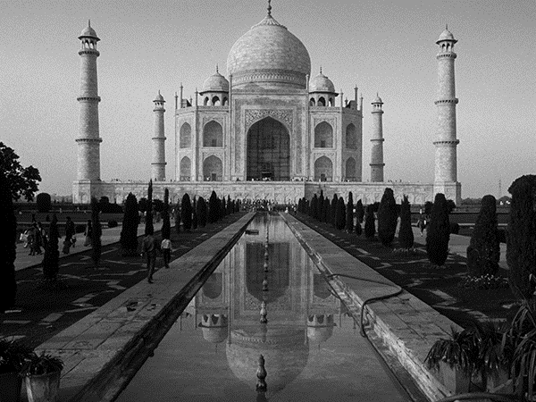
Associated Empire

How was it used to legitimize a ruler’s power?

Identify | 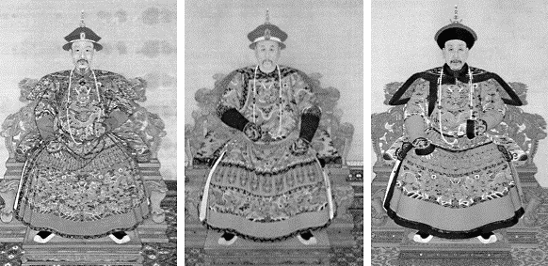
Associated Empire

How was it used to legitimize a ruler’s power?

Identify
Associated Empire

How was it used to legitimize a ruler’s power?

- States treated different ethnic and religious groups in ways that utilized their economic contributions while limiting their ability to challenge the authority of the state. Define the following terms that were created by the Spanish and Portuguese:

Mestizo
Mulatto
Creole

- Recruitment and use of bureaucratic elites, as well as the development of military professionals, became more common among rulers who wanted to maintain centralized control over their populations and resources.

(Options: samurai, examination
system, devshirme)
Empire | Elite / Military Professional | Describe how this helped the ruler maintain centralized control:
Ottoman

China

Japan

- Rulers used tribute collection and tax farming to generate revenue for territorial expansion.

Define tribute: _______________________________________________________________________________

- Imperial expansion relied on the increased use of gunpowder, cannons, and armed trade to establish large empires in both hemispheres.

- How did the European establishment of new trading-post empires in Africa and Asia affect the power of states in the interior of West and Central Africa? (Freemanpedia is a great source for this!)
________________________________________________________________________________________________________________________________________________________________________________________________________________________________________________________________________________________________________________________________________________________________________________________________________

- Land empires expanded dramatically in size.
- European states established new maritime empires in the Americas.

Define maritime: ___________________________________________________________________________________

Sort the following empires into “Land Empire” or “Maritime Empire”: British, Dutch, French, Manchu, Mughal, Ottoman, Portuguese, Russian, Spanish.

Land Empires (4) | Maritime Empires (5)

- Competition over trade routes, state rivalries, and local resistance all provided significant challenges to state consolidation and expansion. Explain how each factor listed below provided a significant challenge to state consolidation and expansion: (Look at the Freemanpedia for these!)

How did this challenge to state consolidation & expansion?
Omani-European rivalry in the Indian Ocean

Ottoman-Safavid conflict

Peasant revolts

Key Vocabulary
Atlantic system Mughal Empire Mercantilism Oceania
Aztec Empire New World Monetization Palace of Versailles
Colonies Protestant Reformation Muscovy Peninsulars
Columbian Exchange Absolute monarchy Qing dynasty Taj Mahal
Conquistadors Bullion Seven years’ War Topkapi Palace
Counter-Reformation Canton system Thirty Years’ War
Holy Roman Empire Chartered companies Tokugawa Shogunate
Inca Empire Enclosure Great Plaza of Isfahan
Jesuits Mamluks Creoles
Mestizos Manchu Forbidden City

