Unit 2 Packet
c. 600 BCE – c. 600 CE

NAME : _______________________________________________

Note: Keep this packet until the end of the year so you can study it!

Timeline

Dates | Event | Location(s)
900 BCE – 600 CE | - Assyrian Empire | Middle East
753 BCE – 476 CE | - Roman Empire (Western Roman empire ended in 476, Eastern empire continued on as Byzantine Empire) | Europe, northern Africa, Eurasia
553 BCE – 651 CE | - Persian Empires | Middle East
c. 500s BCE | - Life of Confucius, Buddha, Lao Tzu (start of Confucianism, Buddhism, and Daoism) | East Asia and India
400s BCE | - Greek golden age of philosophy (Socrates, Plato…) | Europe
322 BCE – 186 BCE | - Mauryan Empire | India
221 BCE – 207 BCE | - Qin Dynasty | China
206 BCE – 220 CE | - Han Dynasty  - Official establishment of the Silk Road | China
100s CE | - Start of Christianity | Middle East
200s – 900s | - Golden age of Maya civilization | Mesoamerica
300s | - Start of Trans-Saharan trade route | Northern Africa
320 – 550 | - Gupta Empire | India

Chapter 2: Classical Civilization: China
Chapter 3: Classical Civilization: India
Chapter 4: Classical Civilizations in the Mediterranean and Middle East
Chapter 5: The Classical Period: Directions, Diversities, and Declines by 500 CE
Key Concept 2.1 The Development and Codification of Religious and Cultural Traditions

- Organization and further developments of religious traditions gave people two things: a common bond and an ethical code to live by.

- Jews were conquered by various groups (Assyrian, Babylonian, and Roman empires) at different times, which caused “Jewish diasporic communities” around the Mediterranean and Middle East.

Define Diaspora: ___________________________________________________________________________________
__________________________________________________________________________________________________

- The core beliefs outlined in the Sanskrit scriptures formed the basis of the Vedic religions, which later became Hinduism. Define/explain the following core beliefs of Hinduism (look in Chapter 3)

Brahma
(p68 – 69)
Reincarnation
(p69)
Caste System
(p63 – 64)

- New belief systems and cultural traditions emerged and spread, often establishing universal truths.

- Complete the grid below about Buddhism: (p70 – 71)

BUDDHISM
Theism (mono, poly, etc) |  | Key God(s)
Relative Location |  | Key Figures/Prophets
Approx. Founding |  | Moral Philosophy/Main Ideas
Religious Text(s)

Explain how the following caused Buddhism to spread throughout South Asia: (p70 – 71)

Ashoka

Monasteries

- Complete the grid below about the Confucian philosophical system: (p48 – 49, 53 – 54)

CONFUCIANISM
Theism (mono, poly, etc) | Not a religion, a “system of ethics” | Approx. Founding
Relative Location |  | Key Figures/Prophets
Key Text(s)
Moral Philosophy/Main Ideas

During the time of Confucius, the Five Classics were written/edited and became the basis for the civil service examinations. What were the civil service exams? _________________________________________________________
____________________________________________________________________________________________________________________________________________________________________________________________________

- Complete the grid below about Daoism: (p50 – 51)

DAOISM
Theism (mono, poly, etc) | Not a religion, just a belief system | Key God(s)
Relative Location |  | Key Figures/Prophets
Approx. Founding |  | Moral Philosophy/Main Ideas
Religious Text(s)

Daoism influenced medical practices and architecture:
- Use of acupuncture
- Architecture blended with landscape

- The grid below is about Christianity:

CHRISTIANITY
Theism (mono, poly, etc) | Monotheistic (some say it’s polytheistic) | Key God(s) | God
Relative Location | Jerusalem/Middle East | Key Figures/Prophets | Jesus – son of God
Approx. Founding | 1st century CE | Moral Philosophy/Main Ideas
Religious Text(s) | - Christian Bible  - 10 Commandments | - Jesus died to save all people in the world  - One must believe in God/Jesus and do good things in order to achieve eternal salvation

Explain how the following caused Christianity to spread throughout Afro-Eurasia: (p120 – 124)

Emperor Constantine: Ruler of Roman Empire who made Christianity the official religion of the empire. Commissioned Christian churches to be built around Constantinople (the capital).

Missionaries:

- The core ideas in Greco–Roman philosophy and science emphasized logic, empirical observation, and the nature of political power and hierarchy.

- Fill the grids below as examples of how art and architecture reflected the religions and belief systems:
(Options: Hindu, Buddhist, Greco-Roman)

Identify  The Great Stupa (Ruwanweliseya) | 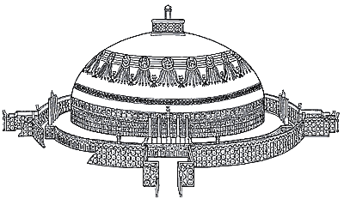
Religion associated with the image

Identify a unique characteristic of the art/architecture
This style generally has a dome and is surrounded by a fence.

Identify
Angkor Wat
Religion associated with the image

Identify a unique characteristic of the art/architecture
This style is meant to resemble Mt. Meru, home to the religions deities.

Identify  Parthenon | 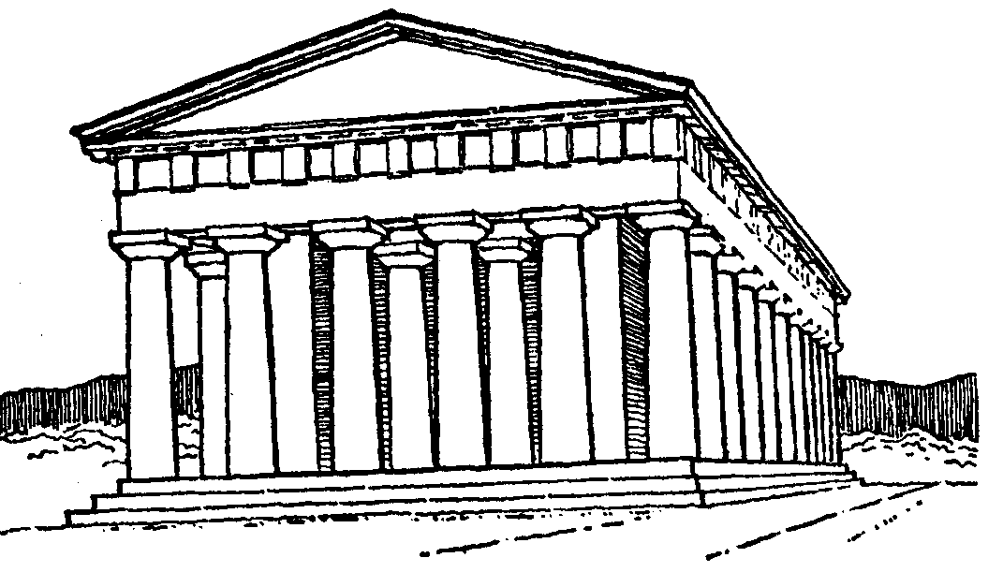
Religion associated with the image

Identify a unique characteristic of the art/architecture
This style consists of straight lines, tall columns made of stone, and symmetry.

- Belief systems generally reinforced existing social structures while also offering new roles and status to some men and women. For example, Confucianism emphasized filial piety, and some Buddhists and Christians practiced a monastic life. Define the following: (not specifically in the book)

Filial piety: ________________________________________________________________________________________
__________________________________________________________________________________________________
Monasticism: ______________________________________________________________________________________
__________________________________________________________________________________________________

Look at pages 118 – 122 in the textbook. Give at least ONE specific example for each question:

How have religious beliefs/practices reinforced existing social structures?
How have religious beliefs/practices impacted roles and status of men?
How have religious beliefs/practices impacted roles and status of women?

- Other religious and cultural traditions continued parallel to the codified, written belief systems in core civilizations.

 | Define the following and give an example | Where did it persist? (Where was it)
Shamanism | A religion that is characterized by belief in an unseen world of gods, demons, and ancestral spirits responsive only to the shamans (medicine man or woman) | Northern Europe  Siberia
Animism  (p124) |  | Africa  Americas
Ancestor Veneration  (Think Mulan) |  | Africa  East Asia  Andes  Mediterranean

Key Concept 2.2 The Development of States and Empires

- The number and size of key states and empires grew dramatically as rulers imposed political unity on areas where there originally were no competing states. On the map provided, label the key states and empires by using different colors:
- Mesoamerica: Teotihuacan, Maya city-states
- Andean South America: Moche
- North America: from Chaco to Cahokia
- Southwest Asia: Persian empires
- East Asia: Qin and Han empires
- South Asia: Mauryan and Gupta empires
- Mediterranean region: Phoenicia, Greek city-states, and Roman empires

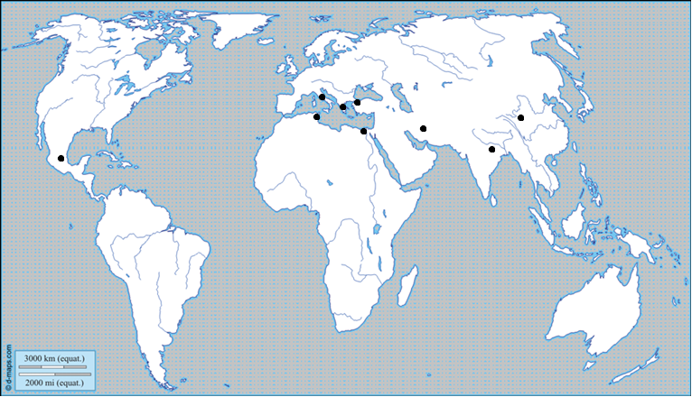

Then label the following imperial cities: (Note: see the dots on the map)
Persepolis Pataliputra Carthage Alexandria Teotihuacan
Chang’an Athens Rome Constantinople

- Select ONE of the imperial cites listed above to answer the following questions:

How did the city serve as a center of trade?

How was it an example of public performance of religious rituals?

What was its political administration like?

- Empires and states developed new techniques of imperial administration.

- In the grid below, explain how in these regions rulers created administrative institutions, including centralized governments/bureaucracies as well as elaborate legal systems:

 | Centralized Government, Bureaucracy, and/or Legal System
China
(p46 – 48)
Persia  (p83 – 84) | - Authoritarian-style rule with local officials (satraps) to carry out orders  - Centralized tax collection  - Had an established court system
Rome
(p90 – 92)
South Asia
(p66 – 67)

- Select ONE imperial government listed above and explain how it promoted trade and military power over areas by each of the following:

 | Civ 1: | Persia
Issuing Currency |  | Gold coins used since Cyrus the Great (c. 550 – 530 BCE)
Diplomacy |  | Tolerance of neighboring languages, cultures, etc
Development of  Supply Lines |  | Paved road systems with rest stops and postal service
Construction of Fortifications, Defensive Walls, and Roads |  | Persian emperor Darius I rebuilt Royal Road to improve trade/travel
Expanding the Military by Drawing from New Locations or Conquered Populations

- Unique social and economic dimensions developed in imperial societies in Afro-Eurasia and the Americas.

A. The social structures of empires displayed hierarchies that included cultivators, laborers, slaves, artisans, merchants, elites, and caste groups. Provide an explanation of social/economic/political/religious hierarchies within each:

Rome:
South Asia:

- Imperial societies relied on a range of methods to maintain the production of food and provide rewards for the loyalty of the elites. These methods of ensuring production were:
- Slavery
- Rents and tributes
- Peasant communities
- Family and household production
- Corvee labor

Define the following:
Corvee labor
Tribute

- Patriarchy continued to shape gender and family relations in all imperial societies for this period.

- The Roman, Han, Persian, Maurya, and Gupta empires encountered political, cultural, and administrative difficulties that they could not manage, which eventually led to their decline, collapse, and transformation into successor empires or states.

- List factors that led to the collapses of the following empires. Circle or highlight similarities:

Han Dynasty
(p112 – 113)

Gupta Empire
(p113)

Rome
(p113 – 114)

Maurya Empire

Key Concept 2.3 Emergence of Interregional Networks of Communication and Exchange

- Land and water routes became the basis for interregional trade, communication, and exchange networks in the Eastern Hemisphere.

- On the grid below, describe the varying factors for each trade route:

 | Climate / Location | Trade Goods | Ethnicity of People Involved
Eurasian Silk Roads |  | Rice, cotton, silk, tea, porcelain
Trans-Saharan caravan routes
Indian Ocean |  | Rice, cotton
Mediterranean Sea

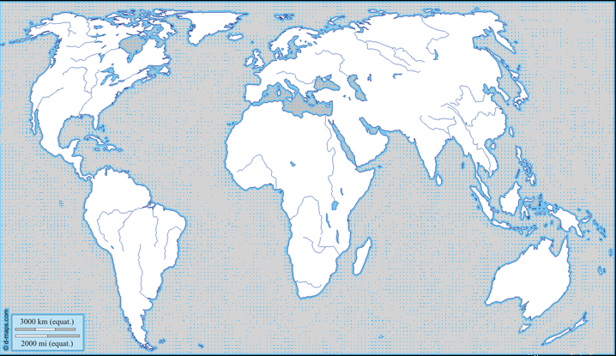
On the map, draw each of the FOUR main trade routes. Try to be as accurate as possible.

- New technologies facilitated long-distance communication and exchange.

- New technologies permitted the use of domesticated pack animals to transport goods across longer trade routes. How does the use of pack animals influence trade? __________________________________________________
____________________________________________________________________________________________________________________________________________________________________________________________________

- Identify and explain ONE maritime innovation that stimulated exchange along routes from East Africa to East Asia: (Options: compass, astrolabe, lateen sail)

Maritime Innovation:

How did a more advanced knowledge of monsoon winds help stimulate trade from Africa to Asia? __________________
____________________________________________________________________________________________________________________________________________________________________________________________________
- In addition to goods being traded, an exchange of people, technology, beliefs, food, animals, and diseases also took place.

- How does the transfer of crops encourage changes in farming and irrigation techniques?
____________________________________________________________________________________________________________________________________________________________________________________________________________________________________________________________________________________________________________________________________

What is the qanat system? ____________________________________________________________________________
________________________________________________________________________________________________________________________________________________________________________________________________________________________

- Put the following events in the order in which they occurred:
Decline of empires, Spread of diseases through trade, Diminishes urban populations

- For each of the religions listed below, explain where they spread to and how they changed during this time:

 | Where it spread | How it Changed
Christianity  (p120 – 122) | Europe
Buddhism  (p118 – 120) | China, Southeast Asia

Key Vocabulary
Stupa
Buddha
Confucius
Jainism
Christianity
Confucius
Cyrus the Great
Royal Road
Daoism
Legalism
satraps
Shamans
White Huns
Yellow Turban Revolution

Diaspora
Reincarnation
Caste system/varnas
Monotheism
Polytheism
Missionary
Filial Piety
Monasticism
Shamanism
Animism
Ancestor veneration
Shi Huangdi
Zhou dynasty
Qin dynasty
Han dynasty
Great Wall
Maurya
Gupta
Ashoka
Rome
Currency
Bureaucracy
Fortification
Hellenism
Corvee labor
Chattel slavery
Tribute
Silk Road
Trans-Saharan trade route
Alexander the Great
Julius Caesar
Oligarchy
Democracy
Syncretism
Sanskrit

