Names of group members:

French Revolution and Napoleon Document Analysis
(Documents begin on the next page)

Document | Target Skill | Analysis
1: Declaration of the Rights of Man | Context  Provide historical context that situates the document in global history.
2: Women’s March on Versailles | Causation  Analyze the painting, and in what ways the painting represents either causes or effects of the revolution.
3: Olympe de Gouge Introduction | Sourcing  Explain the purpose of This document
4: Guillotining of Louis Cartoon | Sourcing  Why would this document be published in England?
5: Napoleon’s Civil Code Declared | Context  Provide historical context that situates the document in global history.
6: Napoleon as a Legislator Painting | Comparative  Compare Napoleon’s use of propaganda in this painting with that of another leader in world history.
7: Map of Europe in 1812 | Continuity/Change Over Time  Using the map and your knowledge of global events, to what extent did Napoleon change history?

French Revolution and Napoleon Documents for Analysis
Source 1: Declaration of the Rights of Man and Citizen, drafted by General Lafayette (sometimes with Thomas Jefferson) and Honore Mirabeau. Approved by the National Assembly of France, August 26, 1789.
“The representatives of the French people, organized as a National Assembly, believing that the ignorance, neglect, or contempt of the rights of man are the sole cause of public calamities and of the corruption of governments, have determined to set forth in a solemn declaration the natural, unalienable, and sacred rights of man, in order that this declaration, being constantly before all the members of the Social body, shall remind them continually of their rights and duties; in order that the acts of the legislative power, as well as those of the executive power, may be compared at any moment with the objects and purposes of all political institutions and may thus be more respected, and, lastly, in order that the grievances of the citizens, based hereafter upon simple and incontestable principles, shall tend to the maintenance of the constitution and redound to the happiness of all. Therefore the National Assembly recognizes and proclaims, in the presence and under the auspices of the Supreme Being, the following rights of man and of the citizen:
Articles:
1. Men are born and remain free and equal in rights. Social distinctions may be founded only upon the general good.
2. The aim of all political association is the preservation of the natural and imprescriptible rights of man. These rights are liberty, property, security, and resistance to oppression.
3. The principle of all sovereignty resides essentially in the nation. No body nor individual may exercise any authority which does not proceed directly from the nation.
4. Liberty consists in the freedom to do everything which injures no one else; hence the exercise of the natural rights of each man has no limits except those which assure to the other members of the society the enjoyment of the same rights. These limits can only be determined by law.
5. Law can only prohibit such actions as are hurtful to society. Nothing may be prevented which is not forbidden by law, and no one may be forced to do anything not provided for by law.
6. Law is the expression of the general will. Every citizen has a right to participate personally, or through his representative, in its foundation. It must be the same for all, whether it protects or punishes. All citizens, being equal in the eyes of the law, are equally eligible to all dignities and to all public positions and occupations, according to their abilities, and without distinction except that of their virtues and talents.
7. No person shall be accused, arrested, or imprisoned except in the cases and according to the forms prescribed by law. Any one soliciting, transmitting, executing, or causing to be executed, any arbitrary order, shall be punished. But any citizen summoned or arrested in virtue of the law shall submit without delay, as resistance constitutes an offense.
8. The law shall provide for such punishments only as are strictly and obviously necessary, and no one shall suffer punishment except it be legally inflicted in virtue of a law passed and promulgated before the commission of the offense.
9. As all persons are held innocent until they shall have been declared guilty, if arrest shall be deemed indispensable, all harshness not essential to the securing of the prisoner's person shall be severely repressed by law.
10. No one shall be disquieted on account of his opinions, including his religious views, provided their manifestation does not disturb the public order established by law.
11. The free communication of ideas and opinions is one of the most precious of the rights of man. Every citizen may, accordingly, speak, write, and print with freedom, but shall be responsible for such abuses of this freedom as shall be defined by law.
12. The security of the rights of man and of the citizen requires public military forces. These forces are, therefore, established for the good of all and not for the personal advantage of those to whom they shall be intrusted.
13. A common contribution is essential for the maintenance of the public forces and for the cost of administration. This should be equitably distributed among all the citizens in proportion to their means.
14. All the citizens have a right to decide, either personally or by their representatives, as to the necessity of the public contribution; to grant this freely; to know to what uses it is put; and to fix the proportion, the mode of assessment and of collection and the duration of the taxes.
15. Society has the right to require of every public agent an account of his administration.
16. A society in which the observance of the law is not assured, nor the separation of powers defined, has no constitution at all.
17. Since property is an inviolable and sacred right, no one shall be deprived thereof except where public necessity, legally determined, shall clearly demand it, and then only on condition that the owner shall have been previously and equitably indemnified.”

Source 2: Women’s March on Versailles, 5-6 october 1789. Author unknown,
This picture shows the women's march on Versailles. Louis XVI agreed to accompany them back to Paris., 1789
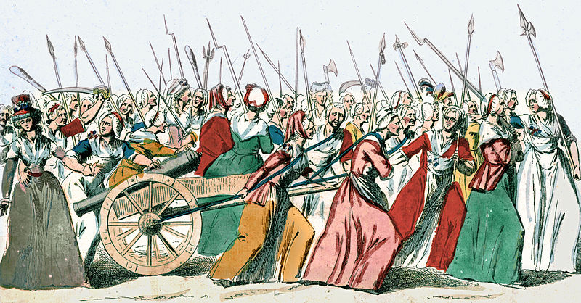

Source 3: Introduction to the Declaration of the Rights of Women, by Olympe de Gouge, 1791.
Olympe de Gouges, a butcher's daughter, wrote the declaration, directly challenging the inferiority presumed of women. Her attempts to push this idea lead to her being charged with treason during the rule of the National Convention. She was quickly arrested, tried, and on November 3, 1793, executed by the guillotine.
“Man, are you capable of being just? It is a woman who poses the question; you will not deprive her of that right at least. Tell me, what gives you sovereign empire to oppress my sex? Your strength? Your talents? Observe the Creator in his wisdom; survey in all her grandeur that nature with whom you seem to want to be in harmony, and give me, if you dare, an example of this tyrannical empire. Go back to animals, consult the elements, study plants, finally glance at all the modifications of organic matter, and surrender to the evidence when I offer you the means; search, probe, and distinguish, if you can, the sexes in the administration of nature. Everywhere you will find them mingled; everywhere they cooperate in harmonious togetherness in this immortal masterpiece.
Man alone has raised his exceptional circumstances to a principle. Bizarre, blind, bloated with science and degenerated--in a century of enlightenment and wisdom--into the crassest ignorance, he wants to command as a despot a sex which is in full possession of its intellectual faculties; he pretends to enjoy the Revolution and to claim his rights to equality in order to say nothing more about it.”

Source 4: “Hell Broke Loose, or, The Murder of Louis. Vide, The Account of that unfortunate Monarch’s Execution.”
As the blade of the guillotine severs the head of Louis XVI, devils stand on the platform and fly overhead, singing “Vive la nation” (“Long live the nation”) and “Ça ira,” the emblematic song of the French Revolution. This British print was published in London just four days after the execution of Louis XVI on January 21, 1793. (British Museum)
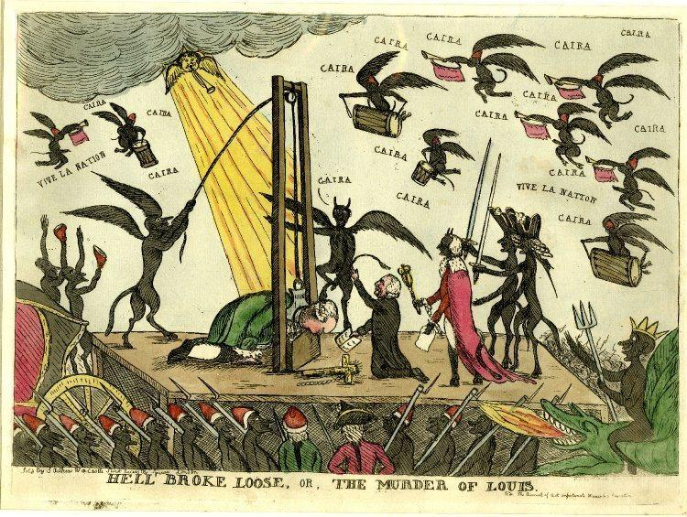
Source 5: The opening of the French Civil Code, Napoleon, 1803-4.

“PRELIMINARY TITLE
Of the Publication, Effect, and Application of the Laws in General.
Decreed 5th of March, 1803. Promulgated 15th of the same Month

Articles
- The laws are executory throughout the whole French territory, by virtue of the promulgation thereof made by the first consul.
They shall be executed in every part of the republic, from the moment at which their promulgation can have been known…
- The law ordains for the future only; it has no retrospective operation.
- The laws of police and public security bind all the inhabitants of the territory.
Immoveable property, although in the possession of foreigners, is governed by the French law.
The laws relating to the condition and privileges of persons govern Frenchmen, although residing in a foreign country.
- The judge who shall refuse to determine under pretext of the silence, obscurity, or insufficiency of the law, shall be liable to be proceeded against as guilty of a refusal of justice.
- The judges are forbidden to pronounce, by way of general and legislative determination, on the causes submitted to them.
- Private agreements must not contravene the laws which concern public order and good morals.”

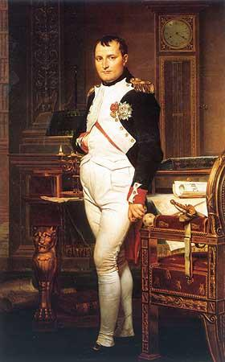
Source 6: The Emperor as Legislator, Jacques Louis David, 1812. Washington National Gallery of Art.

“Totally unlike traditional portraits of sovereigns in their robes of state, this standing portrait is a realist allegory of the emperor’s civilian activities… The candles are burned down, the clock shows four in the morning, his pen and paper are thrown down on the desk, everything is designed to imply that he has just spent all night working on the Code Civil. Dawn is rising and the emperor is preparing to go and review his troops. The picture’s message is clear: the military leader is also a powerful statesman, administrator and legislator, whose capacity for work is unparalleled.”
– Napoleon Foundation

Source 7: Map of Europe, 1812, made in 1888.
